Celiac Disease

A Condition You Can Manage
If you have celiac disease, eating gluten damages the tiny finger-like folds in the wall that line the upper part of your small intestine. These folds are called villi.
Gluten is a protein in wheat, barley, and rye. These grains are used to make bread, pasta, cereal, baked goods, and other foods.
The damage in the small intestine prevents your body from absorbing nutrients from all foods. Eventually, this malabsorption can cause other health problems such as a bone disease called osteoporosis, or anemia, which is iron deficiency. In children, malabsorption also can delay growth and development.
There is no cure for celiac disease. But following a gluten-free diet can help manage your symptoms, promote healing in your intestines, and prevent long-term complications. Most often, people who have celiac disease are happily surprised by how much better they feel when they follow a gluten-free diet.
Celiac disease also is called celiac sprue, nontropical sprue, or gluten-sensitive enteropathy.
This information is about celiac disease. It explains:
- Symptoms.
- Causes.
- How it is diagnosed.
- Possible complications.
- Treatment.
If you have questions about this information, talk with your health care provider.

Your Digestive System
Learning about your digestive system can help you better understand celiac disease. Your digestive system includes your esophagus, stomach, small intestine, large intestine (colon), and rectum. See Figure 1.
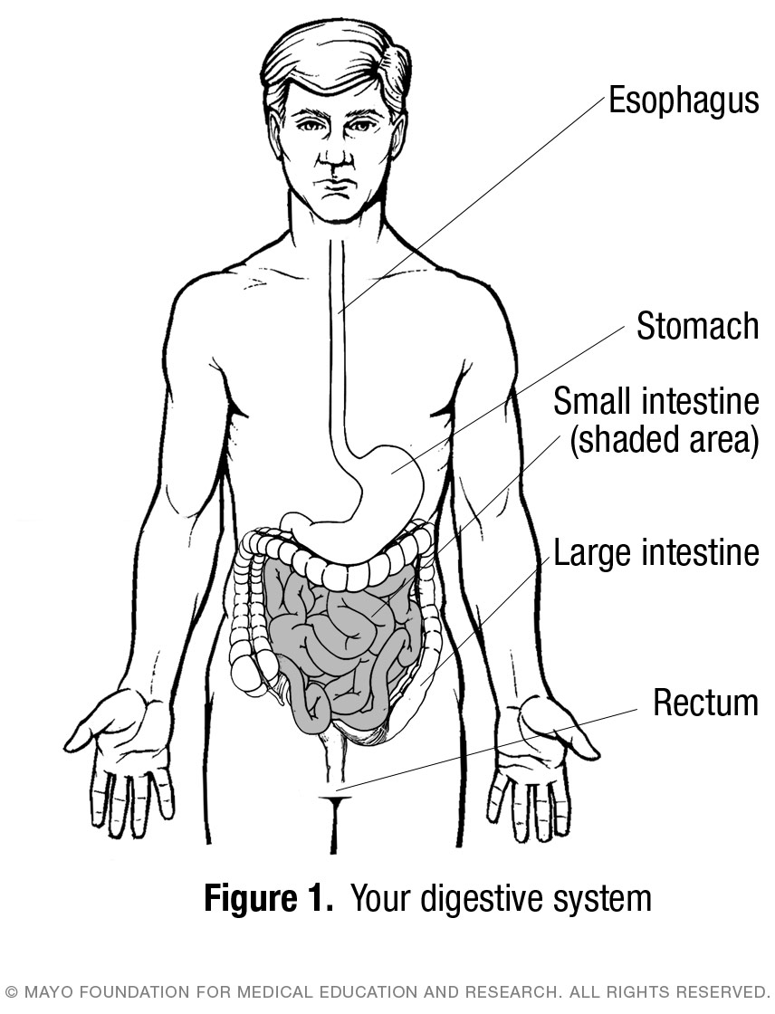
Digestion begins when you chew and swallow your food. After you swallow, food moves down your esophagus into your stomach. From there it goes into the small intestine where your body absorbs most of its nutrients.
The surface of the small intestine is covered with villi. These are tiny finger-like folds in the wall of the intestine that help absorb vitamins, minerals, and other nutrients from food. See Figure 2.
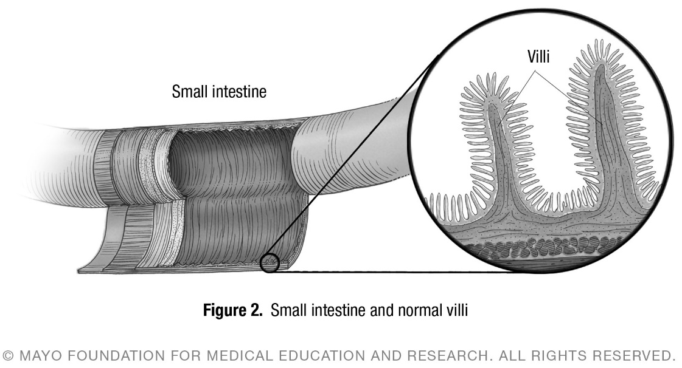
In celiac disease, the villi in the wall of the small intestine are damaged. They are not able to absorb vitamins, minerals and other nutrients from food, no matter how much you eat. See Figure 3.
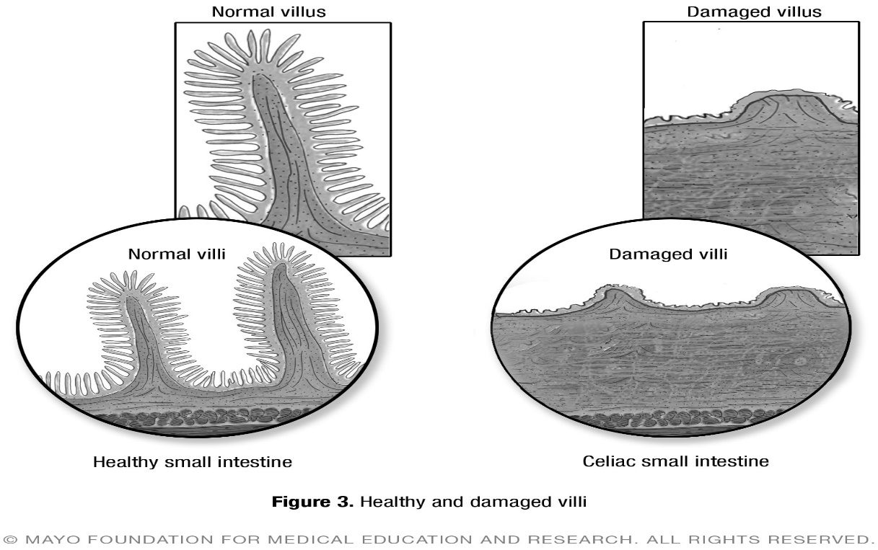

An Autoimmune Disorder
The immune system is an essential part of the body’s ability to fight infections. It can tell the difference between the body and outside attackers such as infections. The immune system makes antibodies to protect the body from infection.
Sometimes the immune system attacks and damages healthy cells and tissues. This is known as an autoimmune disorder. Autoimmune disorders can affect many parts of the body including joints, pancreas, blood vessels, and nerves.
No one knows what causes autoimmune disorders. They tend to run in families. If you have one autoimmune disorder, you are more likely to have another.
Celiac disease is considered an autoimmune disorder. For those who have celiac disease, their immune system sets up an abnormal reaction, or response, to gluten.
The immune system response with celiac disease is different from the immune system response that happens with an allergic reaction. An allergic reaction tends to happen within seconds or minutes. With celiac disease, the reaction takes hours to weeks.

Symptoms of Celiac Disease
The symptoms of celiac disease can vary a lot and are different in children and adults. Some people have ongoing symptoms. Others have symptoms from time to time. Some people’s symptoms are severe while others have less noticeable symptoms.
Some people have no symptoms. They only discover that they have celiac disease when they and their family members are tested for it.
The most common symptoms for adults include:
- Diarrhea.
- Pale, pasty, smelly stools that may float.
- Fatigue.
- Unintended weight loss.
- Bloating and gas.
- Abdominal pain or cramps.
- Upset stomach, nausea or vomiting.
- Constipation.
More than half of adults who have celiac disease have symptoms that are not seemingly related to the digestive system. Celiac disease can cause symptoms in many parts of the body, not just the digestive system. These include:
- Anemia, usually resulting from iron deficiency.
- Itchy, blistery skin rash called dermatitis herpetiformis.
- Mouth sores.
- Loss of bone density called osteoporosis.
- Headaches.
- Problems with mental clarity and attention span.
- Damage to dental enamel and other dental problems.
- Nervous system injury including numbness and tingling in the feet and hands, problems with balance, and cognitive impairment.
- Joint pain.
- Reduced functioning of the spleen called hyposplenism.
- Acid reflux and heartburn.
- Depression.
- Irritability.
- Muscle cramps.
- General weakness.
- Menstrual irregularities, infertility, and pregnancy complications.
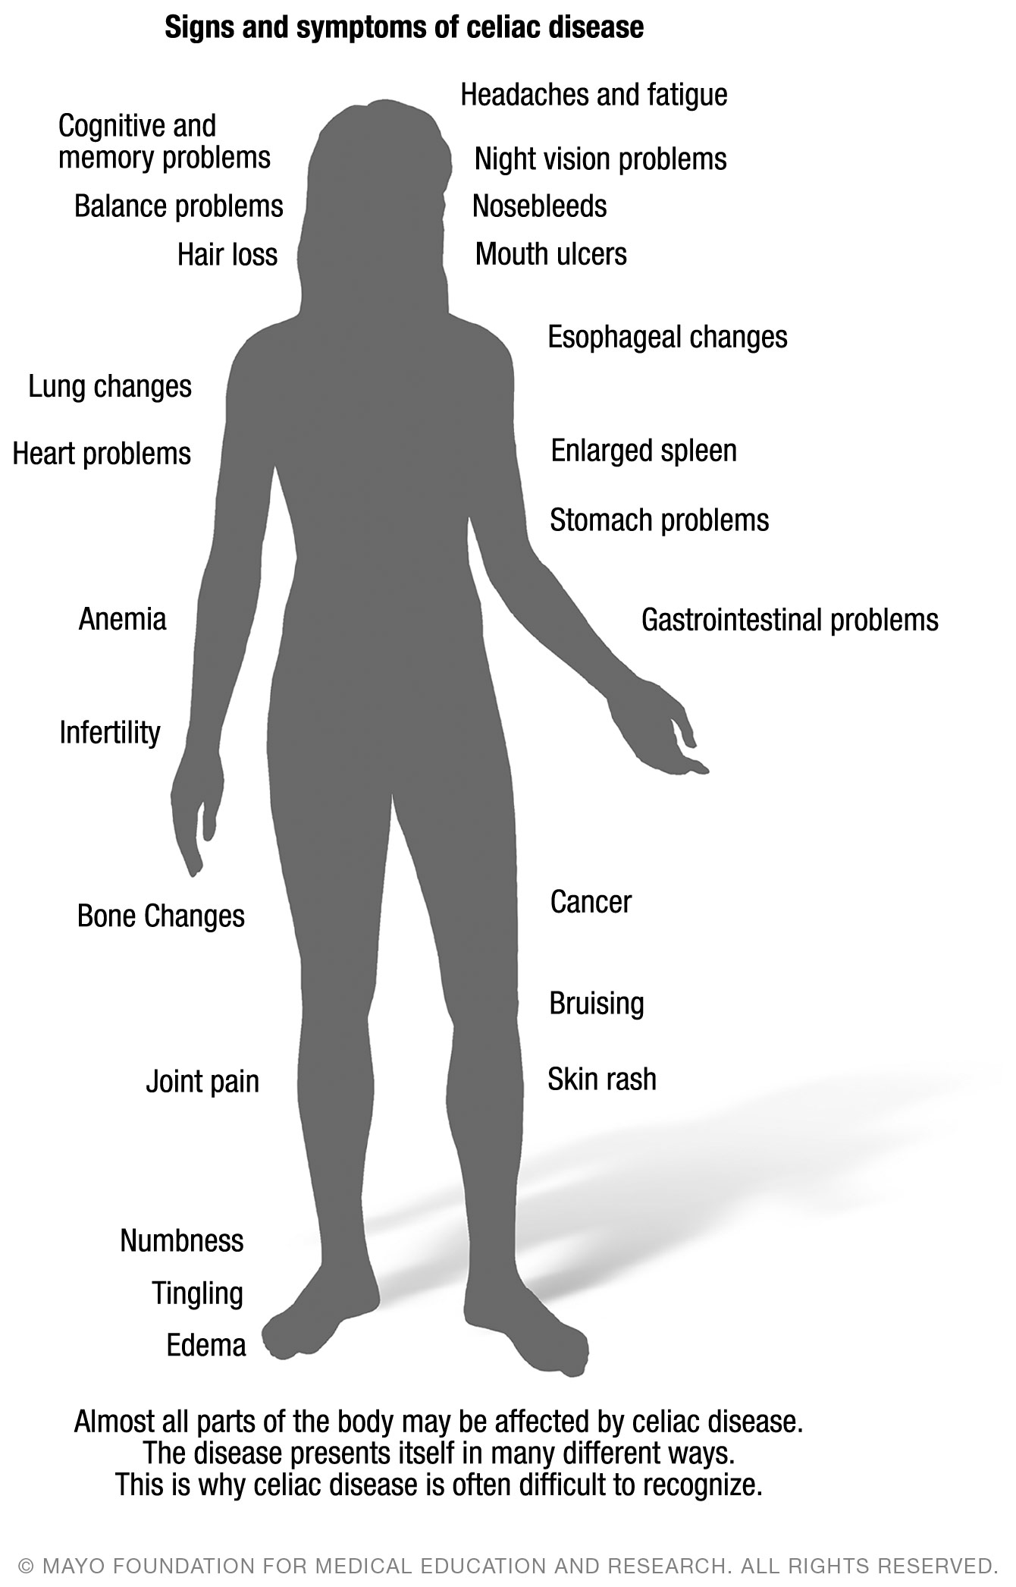
In children less than 2 years old, common symptoms of celiac disease include:
- Vomiting.
- Chronic diarrhea.
- Swollen belly.
- Failure to grow.
- Poor appetite.
- Muscle wasting.
Older children may have:
- Diarrhea.
- Constipation.
- Weight loss.
- Irritability.
- Softening of bone called osteomalacia.
- Short stature.
- Delayed puberty.
- Neurological (nervous system) problems. These include attention-deficit/ hyperactivity disorder (ADHD), learning disabilities, headaches, lack of muscle coordination and seizures.

When to contact your health care provider
If you have symptoms of celiac disease or have a family member with the disease, contact your health care provider about testing. Also, if you have a child who is not growing normally or has other symptoms of celiac disease, talk with your child’s health care provider.
Some symptoms may be a sign of other conditions. For example, some gastrointestinal (GI) symptoms of celiac disease are like those of other GI conditions. These include irritable bowel syndrome, lactose intolerance, Crohn’s disease or parasite infections.
It is important to get medical advice and be tested for celiac disease before you start a gluten-free diet. If you stop eating gluten or reduce how much of it you eat before you are tested for celiac disease, your test results may not be correct. The result may be a false negative for celiac disease.

Causes of Celiac Disease
Celiac disease happens when your genes interact with foods that have gluten in them. Other factors also may play a role with this interaction. But the exact cause of celiac disease is not known.
Celiac disease can happen at any age, once gluten is added to the diet. It tends to run in families, but not always. You have a greater chance of getting celiac disease if a member of your family has it.
Infant feeding practices including the amount of gluten in the diet, gastrointestinal infections and gut bacteria may contribute to developing celiac disease. Sometimes celiac disease starts or becomes active for the first time after surgery, pregnancy, childbirth, intestinal infection, or severe emotional stress. Breastfeeding does not protect against celiac disease.

Who gets celiac disease
Celiac disease can affect anyone, but it seems to be more common in people who:
- Have a family member with celiac disease or dermatitis herpetiformis.
- Have an autoimmune disorder such as type 1 diabetes, thyroid disease or rheumatoid arthritis.
- Have Down syndrome, Turner syndrome or Williams syndrome.
- Are of European or Caucasian descent.
- Are from North Africa, North India, and the Middle East.
Celiac disease is more common in the United States than previously thought. About 1 in 140 people have it, although many do not know it.
Celiac disease may be underdiagnosed because many of the symptoms are like those of other conditions or because people have no symptoms or only mild symptoms.

How Celiac Disease Is Diagnosed
Blood tests can be done to detect celiac disease. The tests check the levels of certain antibodies in your body. That can determine whether you need more testing.
Antibodies are in your blood and are a part of your immune system. They fight what they see as foreign substances, including bacteria, viruses and chemicals. In celiac disease, gluten is seen as a foreign substance by certain antibodies. The antibodies anti- tissue transglutaminase, anti-endomysium, and anti-deamidated gliadin are higher than normal in people who have celiac disease.
Please note. It is important to be tested for celiac disease before you start a gluten-free diet. If you stop eating gluten or reduce how much of it you eat before you are tested for celiac disease, your test results may not be correct.
To confirm a celiac disease diagnosis after an elevated blood test result, an endoscopy to look at your small intestine usually is done. After you receive anesthesia or sedation, a thin tube is moved down your esophagus through your stomach to your small intestine. Small samples of tissue are taken from your small intestine. This is called a biopsy. The samples are examined for damage to the small intestine.
You may have heard of gluten sensitivity as something other than celiac disease. Some people avoid gluten for reasons other than celiac disease. They may have had some type of allergy test. Allergy tests and food sensitivity tests cannot test for celiac disease. It is important to be tested with an antibody test and a small intestine biopsy for celiac disease before you start a gluten-free diet.

Possible Complications
If celiac disease is not treated correctly, it can lead to serious health problems. However, once it is managed with a gluten-free diet, the risk for these health problems lessens. People who already have complications of celiac disease may see improvements in their health after they follow a gluten-free diet.

Malnutrition
Celiac disease damages the small intestine. Then the small intestine cannot absorb the nutrients your body needs. This can lead to vitamin and mineral deficiencies and weight loss. In children, malnutrition can delay or slow growth and development.

Anemia
Iron is one nutrient the small intestine cannot absorb if you have celiac disease. This can result in low iron in your blood, called anemia. Anemia causes tiredness and other health problems.

Loss of calcium and bone
Calcium and vitamin D are two nutrients the small intestine cannot absorb with celiac disease. This can result in the loss of bone density in adults, which can lead to osteoporosis. In children, lack of these nutrients can soften their bones and lead to osteomalacia or rickets.

Lactose intolerance
Damage to your small intestine may cause you to have problems digesting food or liquids that contain lactose, even if they do not contain gluten. Lactose is a natural sugar in milk and other dairy products. You may have abdominal pain or diarrhea after you eat or drink dairy products. This is called lactose intolerance.
As their intestine heals after following a gluten-free diet, some people find their lactose intolerance goes away. However, others continue to have lactose intolerance despite managing their celiac disease with a gluten-free diet.

Cancer
People with celiac disease have a greater chance of getting some types of cancer, especially cancer of the bowel or intestinal lymphoma. This small risk usually lessens once people follow a gluten-free diet and the intestine heals.

Nervous system problems
Some people who have celiac disease may develop neurological problems. These can include loss of balance, thinking impairment, and seizures. Some people have peripheral neuropathy. This is a nervous system disease that causes numbness and tingling in the feet and hands.

Treatment
You can control celiac disease. Although there is no cure, you can follow a gluten-free diet to manage celiac disease.
Usually, several weeks after you remove gluten from your diet, the inflammation in your small intestine generally begins to lessen. The small intestine begins to heal. You begin to feel better. Complete healing and regrowth of the villi may take several months or years. Healing in the small intestine tends to happen more quickly in children than adults.
Your health care provider may recommend that you take medication to help heal your small intestine or treat any condition associated with your celiac disease. However, most people manage celiac disease with only a gluten-free diet. Also, you may need to take vitamin and mineral supplements until your intestine heals or possibly for the rest of your life.
Living with celiac disease can be a challenge. It takes time and patience to learn how to follow a gluten-free diet. However, you will feel better and with experience, you will find it easier to manage a gluten-free lifestyle. Remember, you are in control of what you eat and drink.
Foods can have gluten in them even though you do not expect them to. For this reason, you are strongly encouraged to talk with a registered dietitian who is familiar with instructing people on a gluten-free diet. It also can be helpful to work with a dietitian as you plan, adapt to and maintain a healthy, nutritious, gluten-free diet.

You must avoid gluten
Any food that contains gluten is off limits for you. Gluten is a protein in wheat, barley and rye. These grains are used to make bread, pasta, cereal, baked goods and other foods.
Also, many other foods have ingredients that contain gluten or can be contaminated during processing. These include soups, chips, sauces, foods that contain malt, French fries, processed meats and others. Gluten also can be in preservatives and other additives.
Most plain meats, vegetables and fruits, as well as dairy products, rice, corn and potatoes do not contain gluten. Also, gluten-free substitutes are available. Ask your dietitian what to look for when you shop for gluten-free products and substitutes.
It is important to not eat gluten-free foods that may have come into contact with foods that do contain gluten. Be aware that this cross-contamination can happen at home, in restaurants or at places where food is made.
Talk with your dietitian about resources and celiac disease support groups.
Read food labels. If a product has a label that shows it is FDA approved as gluten- free, it should be fine. A dietitian can give you tips on what to look for on food labels. If it is not clear from the label whether a product contains gluten, call the manufacturer. Do not eat the food if you are not sure whether it contains gluten.
Adapt your favorite recipes. If your favorite foods contain gluten, you may be able to substitute gluten-free items and still eat them.
When you eat out, you can call a restaurant first to ask about its gluten- free options. More and more restaurants offer gluten-free items.
You do not have to worry about gluten in things you do not eat such as shampoo or body lotion. However, you should make sure items you put in or on your mouth do not contain gluten. These include:
- Prescription and over-the-counter medications, vitamin and mineral supplements, herbal and nutritional supplements.
- Toothpaste and mouthwash.
- Lipstick and other products you wear on your lips.
- Communion wafers.
- Play-Doh, putty and other similar products children play with.

A gluten-free diet must be followed for life
If you stop following the gluten-free diet, eventually you may have symptoms and your intestine will become damaged again. Even tiny amounts of gluten in your diet can cause damage, whether or not they cause symptoms. And damage to your small intestine can lead to health problems and celiac disease complications.
If you accidentally eat a product that contains gluten, you may have abdominal pain and diarrhea. Some people have no symptoms, but this does not mean it is not harmful.

Follow-up Care
After being diagnosed with celiac disease, you need medical follow-up to make sure your celiac disease responds to a gluten-free diet. Your health care providers also want to be sure you are getting the support you need to maintain the diet for life.
Blood tests are done to check your response. Usually, the results of these tests return to normal once you have been gluten-free for six to 12 months. If test results stay above normal, your health care provider may try to find the reason. Most often, the cause is not intentional but involves hidden gluten in your diet.
If you continue to have symptoms or your symptoms come back, you may need a follow-up endoscopy with a biopsy. This is done to ensure that healing has happened.
Adults usually have a greater need for follow-up testing, although children may require it, too. Adults are recommended to have a follow-up endoscopy two years after their celiac disease diagnosis. Some people have routine small intestine biopsies if they are diagnosed in adulthood, as healing can be slow and uncertain. The risk of complications from celiac disease increases if the intestine does not heal.

Common Questions

How strict do I need to be?
The minimum safe amount of gluten is not known. Even small amounts of gluten may damage the intestine and cause serious, long-term problems. So even if you do not have symptoms, you must follow the gluten-free diet strictly.

Are oats allowed?
If your intestine is healed after one year on a gluten-free diet and you never had severe complications with celiac disease, you may try gluten-free oats. There is a small chance you could have a reaction. If you have even mild symptoms, stop eating the oats. If you eat oats and do not have symptoms, let your health care provider know at follow-up appointments. Do not eat any oats that are not labeled as gluten free.

My teen son recently ate gluten and didn’t get sick. Now he argues that he doesn’t have celiac disease and is eating everything. After five days he still doesn’t have symptoms. Does he have celiac disease?
Your son’s intestine has healed since going on a gluten-free diet. After the intestine heals, the time it takes to develop symptoms is different for each person. Some people with celiac disease have symptoms with their first meal that contains gluten. For others, symptoms may not return for weeks or months. However, damage to the small intestine can happen even if there are no symptoms.

Can I have a genetic test for celiac disease?
Your health care provider may recommend that you have genetic testing to rule out celiac disease when there is uncertainty as to the diagnosis. If the genetic test is negative, you can never get celiac disease. Therefore, you never need to be tested for celiac disease again.
A positive genetic test shows only that you have the gene for celiac disease. It does not mean you have the disease or that you will get it. If your antibody test is negative, it is good to be tested again in the future, as advised by your health care provider, even if you do not have symptoms.

What can I do about my child’s school not helping with gluten-free lunches?
Although schools are required to help with special diets under the Americans with Disabilities Act, they have varying abilities to accommodate special diets. If you are not able to work out a plan with the food service managers, it may be best to send lunch with your child.

What can we do to help our child argue less about the gluten-free diet?
The gluten-free diet is a fact of your child’s life. It may be easier to enforce the gluten- free diet if your family also follows it when you have shared meals. This places fewer temptations in front of your child. However, family members at risk for celiac disease should be tested for it before they reduce gluten in their diet. Let your child select gluten-free foods, including treats.

How do we know if a product is gluten-free if it doesn’t say it on the label?
A dietitian can help you identify words on labels that may mean gluten is in the food. Or you can call the manufacturer of the product or look at the product information online. Do not eat a food if you are not sure whether it contains gluten.

The diet can be restrictive. How can I feel as if I have choices?
The most helpful approach is to focus on what you can eat, which includes a wide variety of healthy foods. Look at this as an opportunity to start a healthier lifestyle.
This material is for your education and information only. This content does not replace medical advice, diagnosis or treatment. New medical research may change this information. If you have questions about a medical condition, always talk with your health care provider.
- © 2017 Mayo Foundation for Medical Education and Research (MFMER). All rights reserved.
MC6050rev1017

