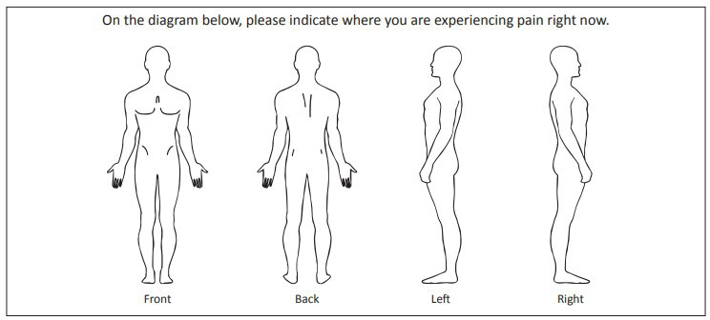

PC506 New Patient Questionnaire

**Document type: Patient Questionnaire**

Circle AVERAGE pain level on a **GOOD** day: Circle AVERAGE pain level on a **BAD** day:

0

0

Revised 2/2022 HIM Approved 3/2020

Does it travel or radiate? **Yes / No** If yes, where to?

**What makes your pain BETTER?**

* Exercise
* Heat/Ice
* Lying down
* Massage
* Pain/Prescription meds
* Pushing a shopping cart
* Sitting
* Standing
* Walking
* Other

**What makes your pain WORSE?**

* Bending
* Climbing stairs
* Going down stairs
* Lifting
* Lying down
* Pushing a shopping cart
* Sitting
* Standing
* Walking
* Other

**Describe your pain**

* Aching
* Burning
* Dull
* Pins & Needles
* Numbness
* Shooting
* Stabbing
* Throbbing
* Other

**Wellstar North Fulton Medical Center  
 Pain & Spine Center** **New Patient Questionnaire**

Patient Name Today’s Date Birthdate Age

Referring Doctor Internist/Family Doctor

Cardiologist/Vascular Neurologist_

Have you seen a Pain Doctor before? **Yes / No** If yes, provide name and practice

How long has your pain been present?

Is your pain from an injury or accident? **Yes / No** If yes, briefly describe what happened

1

1

2

2

3

3

4

4

5

5

6

6

7

7

8

8

9

9

10

10

Page 1 of 3

|  |  |  |  |  |  |
| --- | --- | --- | --- | --- | --- |
| **TREATMENT** | **HELPED?** | **DATE** | **TREATMENT** | **HELPED?** | **DATE** |
| Ice Packs | Y / N |  | Chiropractor | Y / N |  |
| Heating Pad | Y / N |  | Massage | Y / N |  |
| Injection: Epidural | Y / N |  | Acupuncture | Y / N |  |
| Injection: Trigger Point | Y / N |  | Spinal Cord Stimulator | Y / N |  |
| Injection: Other | Y / N |  | TENS Unit | Y / N |  |
| **Opioids (oxycodone, hydrocodone, etc.)** | Y / N |  | **Ibuprofen, Motrin, Aleve, Tylenol, etc.** | Y / N |  |
| **Physical Therapy**  **(# of sessions/Duration)** | Y / N | * | OTHER | Y / N |  |

**Are you ALLERGIC to any of the following? If Yes, list reaction below.**

**Are you ALLERGIC to any Medications Yes / No (If Yes, list medication and reaction below)**

Are you currently taking any **Blood Thinners**? **Yes / No** If yes, please list

Are your current **pain** medications causing any side effects? **Yes / No / N/A**

If yes, please list

Are your current medications for this **pain** increasing your ability to function? **Yes / No / N/A**

If yes, describe how they increase your function?

**CIRCLE Previous Treatments** below that you have tried for your **current pain**

Page 2 of 3

Betadine Yes / No

Latex Yes / No

CT/Contrast Dye Yes / No

Lidocaine/Marcaine Yes / No

Steroids Yes / No

Medication

Reaction

Medication

Reaction

**Pharmacy Name** **City** **Phone**

**CURRENT MEDICATIONS (Attach list as needed)**

|  |  |  |  |  |  |
| --- | --- | --- | --- | --- | --- |
| Medication Name | Dose | Times Per Day | Medication Name | Dose | Times Per Day |
|  |  |  |  |  |  |
|  |  |  |  |  |  |
|  |  |  |  |  |  |
|  |  |  |  |  |  |
|  |  |  |  |  |  |
|  |  |  |  |  |  |

PC506 New Patient Questionnaire

**Document type: Patient Questionnaire**

Revised 2/2022 HIM Approved 3/2020

|  |  |  |  |
| --- | --- | --- | --- |
| **SURGERY** | **DATE** | **SURGERY** | **DATE** |
|  |  |  |  |
|  |  |  |  |
|  |  |  |  |
|  |  |  |  |
|  |  |  |  |
|  |  |  |  |

Page 3 of 3

PC506 New Patient Questionnaire

**Document type: Patient Questionnaire**

Revised 2/2022 HIM Approved 3/2020

Over the last 2 weeks how often have you been bothered by the following:

Little interest or pleasure in doing things: •Not at all •Several Days •More than half the days •Nearly every day

Feeling down, depressed or hopeless: •Not at all •Several days •More than half the days •Nearly every day

Date/ Time

Reviewed by RN

Patient Signature Date/ Time

How many per week?

Other Medical History:

Smokeless Tobacco use: **Current/Former/Never**

Do you use any recreational drugs? (marijuana, cocaine, heroin, etc) **Yes / No** Please list:

Tobacco use: **Current/Former/Never** Packs per day Number of years Quit Date

Do you drink alcohol? **Yes / No**

**Surgical History**

* Concussion
* Conversion Disorder
* COPD
* Coronary Artery Disease
* Deep Vein Thrombosis
* Depression
* Diabetes Mellitus
* Disc problem- Cervical
* Disc problem – Lumbar
* Disc problem- Thoracic
* Fatigue
* Fibromyalgia
* Headaches
* Hepatitis
* History of Blood Transfusion
* HIV/AIDS
* Hyperlipidemia
* Hypertension
* Kidney Disease
* Liver Disease
* Low Back Pain
* Myocardial Infarction
* Neuropathy
* Osteoarthritis
* Pancreatitis
* Psychosis
* Pulmonary Artery Hypertension
* PVD
* Rheumatoid Arthritis
* Schizophrenia
* Seizures
* Sickle Cell Anemia
* Sleep Apnea
* Stroke
* Substance Abuse
* TIA
* Abnormal ECG
* Alcoholism
* Anemia
* Aneurysm
* Anxiety
* A-V Malformation
* Bipolar Disorder
* Cancer
* Carotid Disease
* CHF
* Cirrhosis
* Clotting

Disorder

**Medical History**

Quit Date

Wine / Beer / Shots of Liquor