

**Roosevelt Warm Springs   
Rehabilitation & Specialty Hospitals, Inc.**

**Community Health Needs Assessment**

**May 2022**

|  |  |  |  |  |  |  |  |  |  |  |  |  |  |  |  |  |  |  |  |  |  |  |  |
| --- | --- | --- | --- | --- | --- | --- | --- | --- | --- | --- | --- | --- | --- | --- | --- | --- | --- | --- | --- | --- | --- | --- | --- |
| **TABLE OF CONTENTS**   |  |  | | --- | --- | | 1. Introduction ……………………………………………………………………………………………………… | 3 | | 1. Background ………………………………………………………………………………………………………. | 3 | | 2.1 Organization Structure and History …………………………………………………. | 3 | | 2.2 2022 CHNA team ……………………………………………………………………………… | 4 | | 2.3 Service Area …………………………………………………………………………………….. | 4 | | 2.4 Results of the 2019 CNHA …………………………………………….……………….... | 5 | | 1. Analysis and Current Project ……………………………………………................................... | 7 | | 3.1 Methods …………………………………………………………………………………………..  3.1.1 Primary Data Analysis………………………………………………………..  3.1.2 RWSH Community Survey…………………………………………………. | 7  7  9 | | 3.2 Project (s) Design and Goals .……………………………………………………………. | 10 | | Appendix A: Professional Survey ……………………………………………………………………………………  Appendix B: Professional Survey Results………………………………………………………………………..  Appendix C: General Community Survey ……………………………………………………………………….  Appendix D: General Community Survey Results …………………………………………………………. | 11  13  30  31 | |  |  | |  |

**1. INTRODUCTION**

As part of the Patient Protection and Affordable Care Act, hospitals are required to complete a Community Health Needs Assessment (CHNA) every three years. This is the third CHNA report completed by Roosevelt Warm Springs Rehabilitation & Specialty Hospitals, Inc. (“RWSH”)

RWSH came under the leadership of Augusta University in 2014. In collaboration with Augusta University; a leader in neurological and stroke care, and through its Joint Commission Accredited Stroke Program, the focus of the 2019 Community Health Needs Assessment project for RWSH was stroke care. The results from the 2019 CHNA are found within this CHNA. For the 2022 Community Health Needs Assessment, the focus is upon community wide education.

**2. BACKGROUND**

**2.1 Organization Structure and History**

RWSH was established in 1927 by Franklin Delano Roosevelt and seen as a place of healing and rehabilitation for those with polio. The historic facility in Warm Springs, GA has evolved into today’s RWSH, with an expanded mission to serve as a comprehensive rehabilitation center dedicated to service, technological advancement, program diversity and continuing education on behalf of persons with disabilities. There are now two separate hospitals within this system: Roosevelt Warm Springs Rehabilitation Hospital and Roosevelt Warm Springs Long Term Acute Care Hospital.

AU Health, which is located in Augusta, Georgia, is a cooperate organization of the Board of Regents of the University System of Georgia, and provides support to Augusta University through its Academic Medical Center and other clinical facilities throughout the states of Georgia. This not-for-profit enterprise has a nearly 200-year history of training health professionals for Georgia and nationally, and is known for health-related activities and contributions of its faculty, staff, and students to the uninsured and under-insured members of the community. Augusta University strives to be a top-tier university with a mission of providing leadership and excellence in teaching, discovery, clinical care, and service as a student-centered research university and academic health center. Augusta University embodies the application of research, education, and service to enhance the health of the community, producing tangible and measureable results. AU Health has both nationally and internationally recognized programs in areas such as neurological conditions and stroke, and it has been on the cutting edge of research in such areas as cancer, women’s health, and preventative care.

The mission of RWSH is to provide excellence and leadership in clinical care, service and teaching as patient and family focused rehabilitation and long term acute care hospitals. Our vision is to be destination of choice hospitals for rehabilitation and long term acute care through excellence in patient care, superior clinical education, research, creativity, and an employer of choice. RWSH accepts patients referred from acute care hospitals from Georgia and surrounding states.

In the rehab hospital, patients participate in a structured program that includes building strength, endurance, and self-care while having medical issues managed, preparing patients to return home and resume their lives. The focus is on early intervention for conditions affecting mobility, activities of daily living, and swallowing and cognitive abilities. Part of the day is devoted to follow-up medical care addressing ongoing medical issues and part of the day involves therapy to help the patient build up strength and skills. Psychological support is also offered, as physical trauma can be emotionally draining. Each patient is served by an interdisciplinary team lead by a physician specially trained in physical medicine and rehabilitation. The physician provides daily medical and physical management with the rehabilitation registered nurses providing 24 hour care.  Each patient’s treatment program is individualized and modified according to the progress made toward discharge goals. Other members of the team who work closely to coordinate the patient’s specific treatment include:   Registered Nurses, Physical Therapist, Occupation Therapist, Speech language Pathologist, Psychologist, Respiratory Therapist, Registered Dietician, RN Case Manager/ Discharge Planner, and Clinical Pharmacist.  Additionally, families and primary caregivers are very important members of the team and are encouraged to interact with the team, ask questions, and attend education sessions.

In our LTAC hospital, patients are admitted from an acute care hospital, often from intensive care or step down units, and have an average length of stay with us of 25 days. Our patients are medically complex requiring multi-specialty medical services provided by physicians making daily rounds and registered nurses providing 24 hour complete care. The interdisciplinary team is tailored to the patient’s specific needs and may include Registered Nurses, Respiratory Therapist, Physical Therapist, Occupational Therapist, Speech Language Pathologist, Registered Dietician, Clinical Pharmacist and RN Case Managers/Discharge Planners. We care for critically ill patients who have multiple co-morbidities, multi organ system failure and require specialized care.

**2.2 The 2022 Community Health Needs Assessment Team**

The 2022 CHNA team is made of staff from both the RWSH hospitals including:

* Chief Executive Officer
* Chief Nursing Officer
* Director of Nursing
* Director, Business Development
* Director, Finance
* Director, Case Management
* Director of Ancillary Services
* Director of Quality and Compliance

**2.3 Service Area**

RWSH is located in the city of Warm Springs, Georgia in Meriwether County, which is in mid-Western section of the state. The scope of both the LTAC and the IRF Hospitals’ services are very specialized, and they accept patients from other Georgia hospitals and surrounding states. A*lmost 95%* of the patients have a home address in Georgia. While patients are received from all over the state, the CHNA focused on counties in close proximity to our hospitals and from which we receive the majority of our admissions.

**Table 1: RWSH Long Term Acute Care Hospital Admission Volumes by Top Referring Hospitals, 2019-2021**

|  |  |  |  |
| --- | --- | --- | --- |
| **Hospital** | **Location** | **Admission #s** | **% of Total Admissions** |
| Piedmont Midtown Medical Center | Columbus, GA | 59 | 11.68% |
| Piedmont Newnan | Newnan, GA | 57 | 11.29% |
| St. Francis Hospital | Columbus, GA | 54 | 10.69% |
| Piedmont Fayette | Fayette, GA | 49 | 9.70% |
| Upson Regional | Thomaston, GA | 47 | 9.31% |
| West GA Health System | LaGrange, GA | 29 | 5.74% |
| Piedmont Atlanta | Atlanta, GA | 26 | 5.15% |

*Source: Internal Reporting*

**Table 2: RWSH Rehabilitation Hospital Admission Volumes by Top Referring Hospitals, 2019-2021**

|  |  |  |  |
| --- | --- | --- | --- |
| **Hospital** | **Location** | **Admission #s** | **% of Total Admissions** |
| Piedmont Midtown Medical Center | Columbus, GA | 204 | 15.89% |
| St. Francis Hospital | Columbus, GA | 162 | 12.62% |
| West GA Health Sys | LaGrange, GA | 160 | 12.46% |
| Roosevelt WS LTAC | Warm Springs, GA | 106 | 8.26% |
| GA Regents Medical Center | Augusta, GA | 97 | 7.55% |
| Upson Regional | Thomaston, GA | 95 | 7.40% |
| Piedmont Fayette | Fayette, GA | 80 | 6.23% |

*Source: Internal Reporting*

**2.4 Results of the 2019 CNHA – Tactics to Improve Mental Health Care**

The results of the 2019 Community Health Needs Assessment Survey reflected a need for increased mental health care in our facility as well as in our community. RWSH initiated a 2 fold plan to assist with meeting this need. One initiative focused on tactics to improve mental health care in the patients we serve while the other focused on tactics to improve mental health care in our immediate community. Actions taken included:

* Hiring a full time behavioral health counselor to coordinate mental health care both during and after hospitalization
* Initiating a counselor led support group for patients on our rehab hospital.
* Engaging community pastors to provide spiritual support to our inpatients on a volunteer basis
* Training nurses, physicians and other providers to perform suicide risk assessments using validated tools
* Assisting with behavioral health referrals for follow-up care post discharge by the counselor
* Initiating and supporting an anonymous 12 step group on campus
* Working with Human Resources to facilitate interventions for employees with acute mental health needs

RWSH planned to track these measures by following participation in group therapy sessions, outpatient referrals, and patient satisfaction results collected during post discharge surveys and follow-up calls.

February 2020, RWSH restricted in person meetings as part of our efforts to prevent the spread of Covid-19. This public health emergency remained in place through the end of 2021. RWSH was unable to follow through with group therapy sessions. One on one therapy sessions with the Behavioral Health Counselor remained in place for patients on the rehab and LTAC hospitals as needed.

**Table 3: LTAC response to “Did you receive any mental health care or participate in the support group during your stay?” 2019-2021**

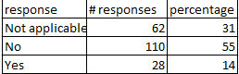

*Source: Internal Reporting*

**Table 4: LTAC response to “Do you feel like your mental health needs were addressed during your stay?”**

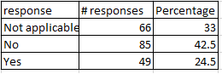

*Source: Internal Reporting*

**Table 5: Rehab response to “Did you receive any mental health care or participate in the support group during your stay?” 2019-2021**

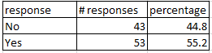

*Source: Internal Reporting*

**Table 6: Rehab response to “Do you feel like your mental health needs were addressed during your stay?”**

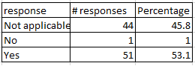

*Source: Internal Reporting*

**3. ANALYSIS AND CURRENT PROJECT**

**3.1 Methods**

**3.1.1 Primary Data Analysis**

**3.1.1a RWSH Patient Data**

RWSH rehab and LTAC hospitals will be covered separately for internal data.

Roosevelt Warm Springs Rehabilitation Hospital is a 52-bed licensed facility that is staffed to accommodate 20 to 24 patients. Looking at calendar years 2019 through 2021, the rehabilitation hospital majority of admissions were related to strokes or other neurological issues (Table 7).

**Table 7: Primary Conditions Seen at RWSRH, 2019 - 2021**

|  |  |  |  |
| --- | --- | --- | --- |
| **Condition** | **2019 # of Admissions** | **2020 # of Admissions** | **2021 # of Admissions** |
| Orthopedic | 53 | 56 | 62 |
| Stroke | 91 | 95 | 98 |
| Neurological | 63 | 96 | 64 |
| General Rehabilitation/ Medicine | 56 | 43 | 69 |
| SCI | 46 | 29 | 26 |
| Amputations | 36 | 39 | 36 |
| Brain Injury | 36 | 37 | 32 |

*Source: Internal Discharge Data*

The Primary payment sources were split between Medicare and another source of payment (Table 8).

**Table 8: Roosevelt Warm Springs Rehabilitation Hospital Admissions by Primary Payer, 2019 – 2021**

|  |  |
| --- | --- |
| **Primary Payment Source** | **Admission Volumes** |
| Medicare Fee For Service | 487 |
| Medicare Advantage | 158 |
| All other | 653 |

*Source: Internal Reporting*

**Table 9: Admissions by Gender at RWSHR, 2019-2021**

|  |  |  |
| --- | --- | --- |
| **Gender** | **# of Admissions** | **Percentage of Admits** |
| Female | 613 | 47.26 |
| Male | 684 | 52.74 |

*Source: Internal Reporting*

**Table 10: Admissions by Age at RWSHR, 2019-2021**

|  |  |
| --- | --- |
| **Age Range** | **Number of Admissions** |
| 17-64 years old | 740 |
| 65+ years old | 557 |

*Source: Internal Reporting*

Roosevelt Warm Springs LTAC Hospital has 32 licensed beds and are staffed for 16-20 patients. Services available include: ventilator weaning, respiratory distress, wound management, status post failed surgery care, and cardiac. Within calendar year 2019 through 2020, the LTAC had the majority of their admissions seen for respiratory conditions and/or skin ulcers (Table 11).

**Table 11: LTAC Admissions by System Impacted or Major Condition, 2016 - 2018**

|  |  |  |  |
| --- | --- | --- | --- |
| **System** | **2019 # of Admissions** | **2020 # of Admissions** | **2021 # of Admissions** |
| Respiratory System | 105 | 120 | 131 |
| Skin, Subcutaneous Tissue & Other | 14 | 17 | 7 |
| Circulatory System | 12 | 3 | 5 |
| Infectious & Parasitic | 7 | 7 | 3 |
| Nervous System | 4 | 1 | 2 |
| Digestive System | 7 | 6 | 0 |

*Source: Internal Reporting*

**Table 12: Roosevelt Warm Springs LTAC Hospital Admissions by Primary Payer, 2019 – 2021**

|  |  |
| --- | --- |
| **Primary Payment Source** | **Admission Volumes** |
| Medicare Fee For Service | 189 |
| Medicaid | 82 |
| Medicare Advantage | 62 |
| All other | 173 |

*Source: Internal Reporting*

**Table 13: Admissions by Gender at RWSH LTAC 2019-2021**

|  |  |  |
| --- | --- | --- |
| **Gender** | **# of Admissions** | **Percentage of Admits** |
| Female | 233 | 46% |
| Male | 274 | 54% |

*Source: Internal Reporting*

**Table 14: Admissions by Age at RWSH LTAC, 2019-2021**

|  |  |
| --- | --- |
| **Age Range** | **Number of Admissions** |
| 17-64 years old | 287 |
| 65+ years old | 220 |

*Source: Internal Reporting*

**3.1.2 RWSH Community Survey**

RWSH conducted two community wide surveys to gather input on what the community views as major health concerns. The surveys requested guidance on how RWSH could assist with meeting those needs.

The “community” was defined as the county in which the hospitals reside as well as the counties of top referral sources.

Both a professional survey and a general community survey via an online survey system were completed. The professional survey was presented to the case managers at the top referring hospitals, low income clinics that service those counties, health departments that service those counties and the chamber of commerce. We had a >60% completion rate on this survey.

A link was provided, via social media, for the general community to complete a survey.

**3.1.2a Professional Survey Results**

The professional survey identified the region’s most prevalent health conditions as Diabetes, Obesity and HTN. It also identified emerging needs among the under-resourced populations as transportation, Covid-19, and the cost of healthcare. The major barriers to obtaining healthcare were identified as transportation, health literacy and cost of care. Education, affordable resources and lack of access to affordable health care were consistently identified as the biggest needs in our community.

**3.1.2b Community Survey Results**

Stress, overeating and high blood pressure were identified as the top three things preventing the survey takers from being as healthy as they would like to be. Greater than 65 percent of those surveyed expressed that they would attend educational sessions provided by Roosevelt. Articles and/or videos posted to social media were consistently identified as the preferred method of providing education to the community. The topics requested to be addressed in this education were tips to eat healthier, simple exercise routines, tips to prevent illness/disease and health care resources that may be available in our community.

* 1. **Project(s) Design and Goals**

Both the professional survey and the general community surveys indicated that easier access to low cost health care/support would assist in making the community healthier. Health Care Literacy was also a theme in the results. 66% of those surveyed were interested in free education from Roosevelt Warm Springs. 62% requested that the education be via social media/online platforms. Disease prevention, simple exercise routines, ways to improve nutritional intake, and available cost effective community resources were a common theme among things that the community would like more information on/things that they could change to improve their health. 58% of those surveyed in the general community survey indicated stress was a barrier to healthy living.

Roosevelt plans to meet these needs by posting free online education a minimum of five times per year. This will be posted to our web page and/or social media platforms (Facebook, Twitter, Instagram, etc.). At a minimum, each of these topics will be covered at least once per year: disease prevention, simple exercise routines, nutritional tips, stress relief tips, and cost effective services/resources in our community.

There are plans for a follow-up with a survey in one year’s time to evaluate the effectiveness of this education. The content will be re-evaluate and timeliness of educational postings will be reassessed. An additional survey will be provided at the two year mark. The success of online education will be determined based on those survey results.

Appendix A:

Professional Survey:

1. For healthcare providers: What age groups do you service?
   1. 17 years & younger
   2. 18-64 years
   3. 65 years & older
   4. N/A- Not a healthcare provider
2. For healthcare providers: What racial/ethnic groups do you primarily service?
   1. White
   2. African American
   3. Hispanic
   4. Asian
   5. Other
   6. N/A- Not a healthcare provider
3. For healthcare providers: What insurance types do you see in your practice?
   1. Medicare
   2. Medicaid
   3. Commercial
   4. Self-Pay
   5. N/A- not a healthcare provider
4. Which of the following are the region’s most prevalent health conditions? (check all that apply)
   1. Diabetes
   2. Asthma
   3. Obesity
   4. COPD
   5. CHF
   6. Depression
   7. Hypertension
   8. Stroke
   9. Mental health
5. Are there any emerging community health needs, especially among under-resourced populations, that were not mentioned previously? (Please be as specific as possible)

FREE TEXT BOX

1. What do you see as major barriers to obtaining health care? (check all that apply)
   1. Transportation
   2. Health literacy
   3. Cost of care
   4. Non-compliance
   5. Access to post-acute care
2. What do you see as the top two most important health issues that need to be addressed in our community?

FREE TEXT BOX

1. What interventions do you think would make a difference?

FREE TEXT BOX

1. How familiar are you with community resources available to you and your patients?
   1. Very familiar
   2. Somewhat familiar
   3. Not familiar
2. If you could make 2-3 changes to promote better health in your community, what would they be?

FREE TEXT BOX

Appendix B:

Professional Survey Results:

Professional CHNA Results 2022:

The Professional CHNA survey was emailed to our top referral hospitals, surrounding health departments, low income clinics and chamber of commerce. We sent to total of 15 people to encompass those places. Initial survey was sent on 12/6/21 with reminder survey link on 12/28/21. Survey was closed on 1/3/22. 11 of the 15 responded! This gave us a 73% completion rate.

Professional survey results below:

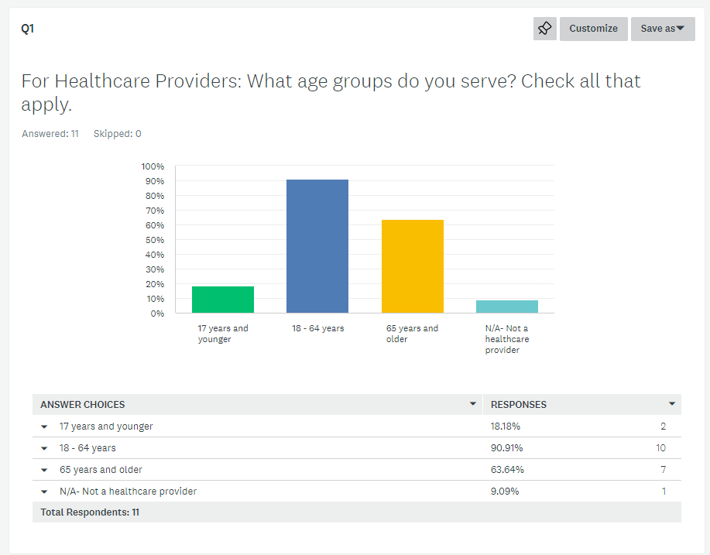

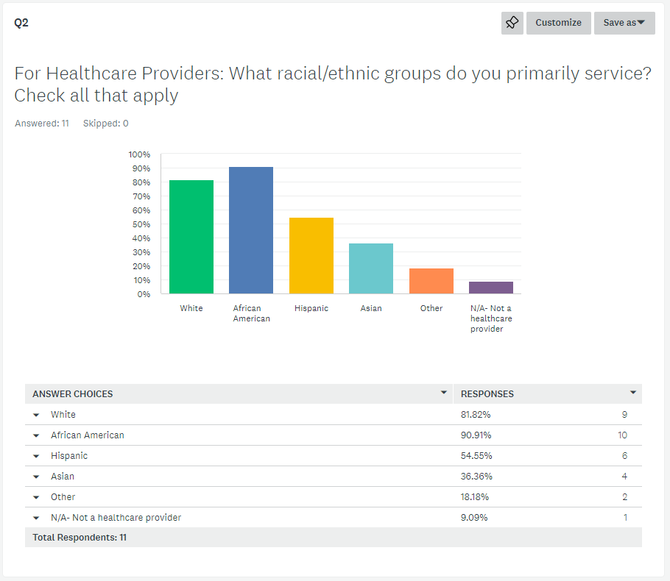

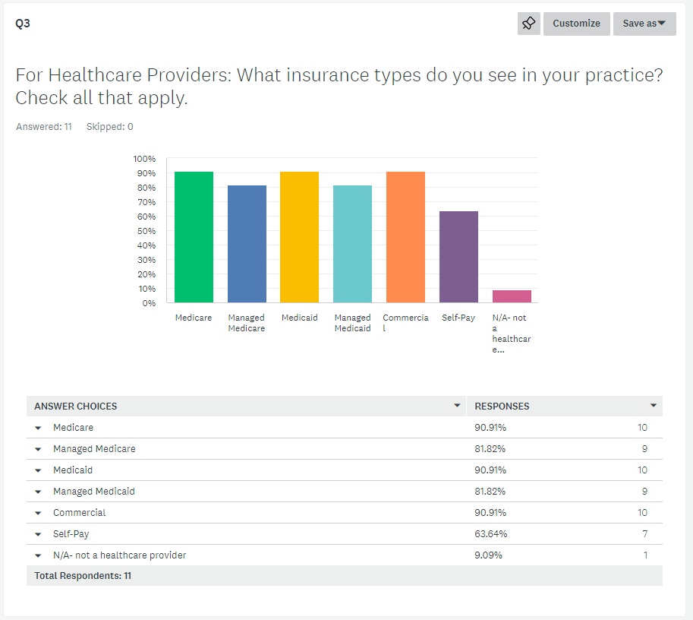

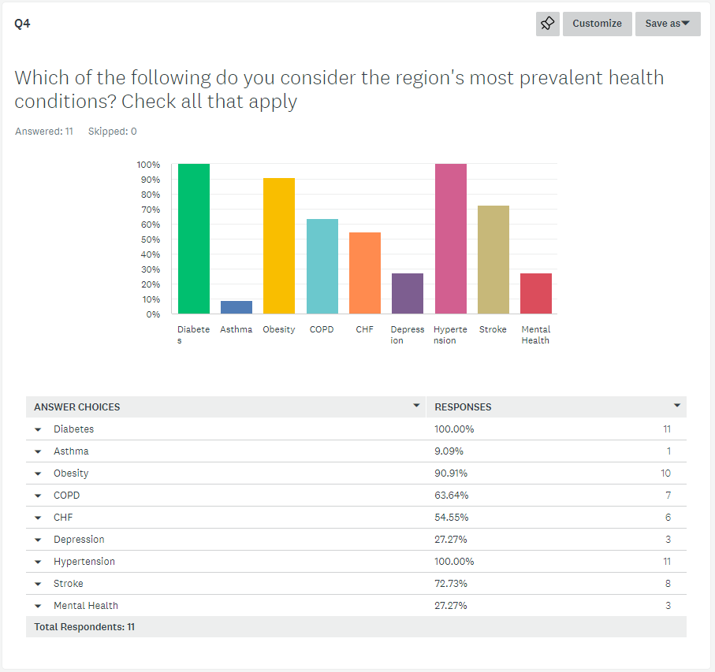

Q5 part 1: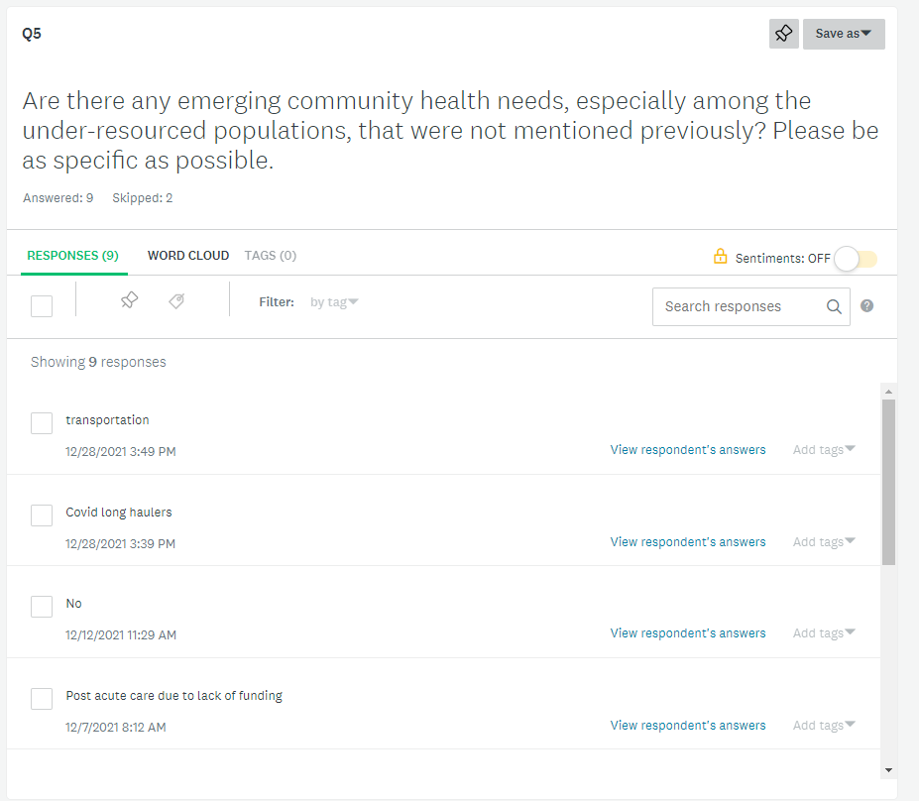

Q5 part 2:

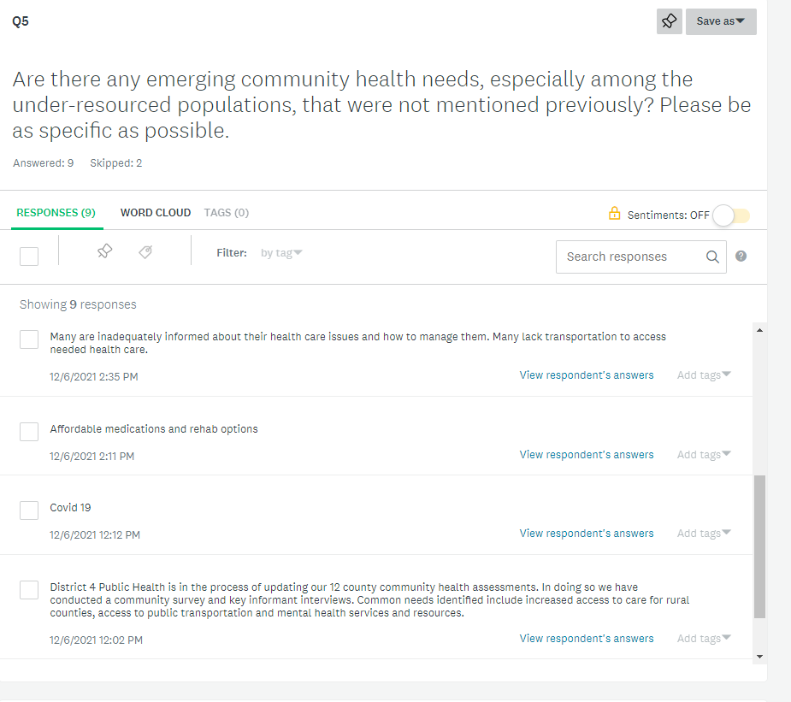

Q5 part 3:

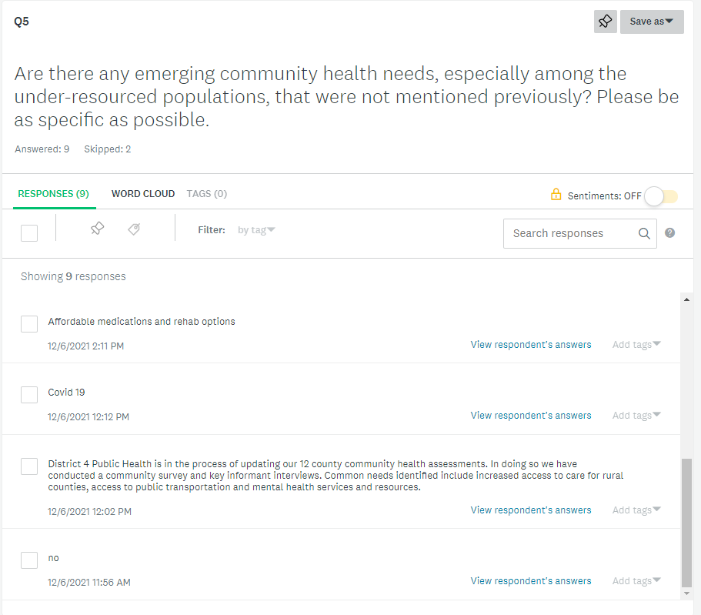

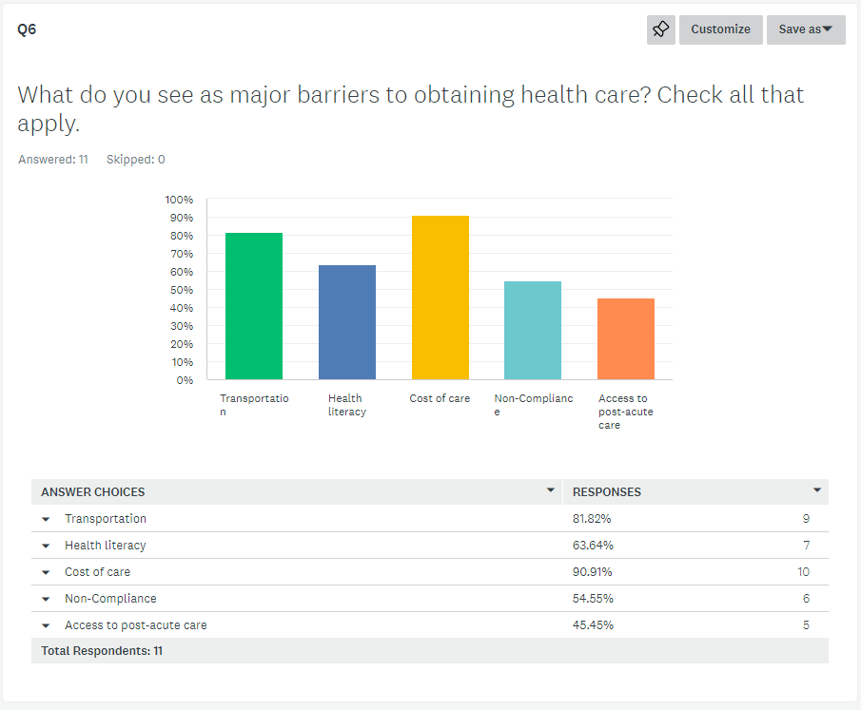

Q7 part 1: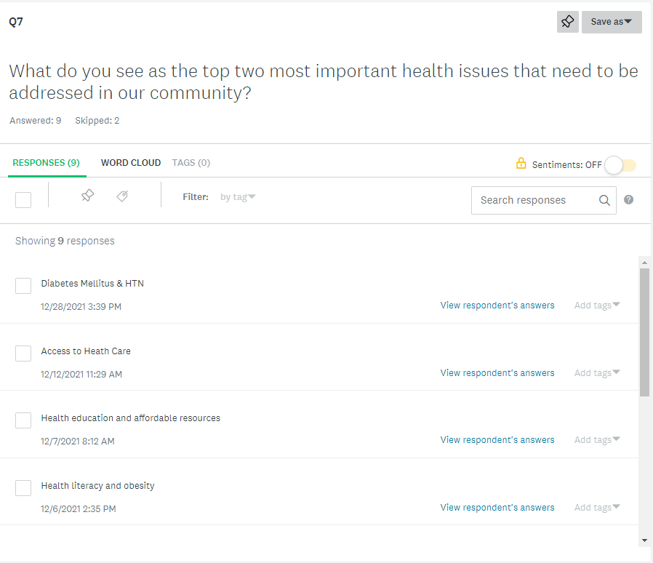

Q7 part 2:

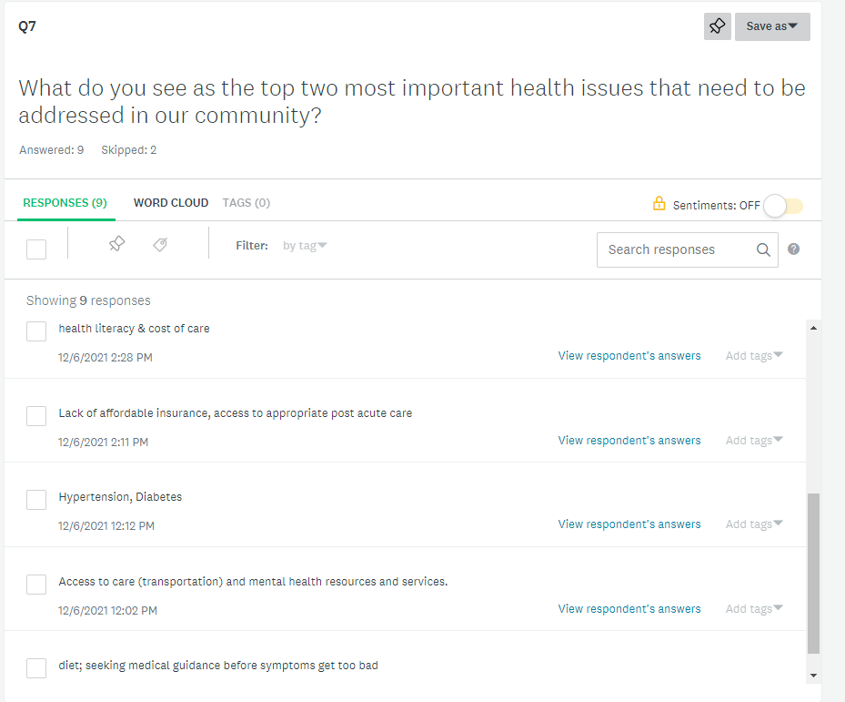

Q8 part 1: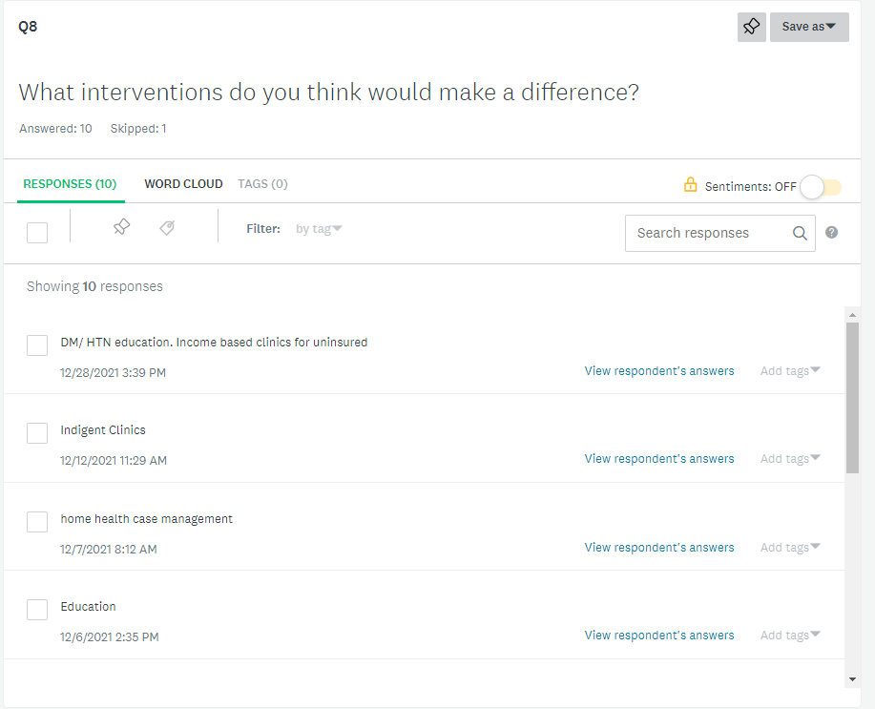

Q8 part 2: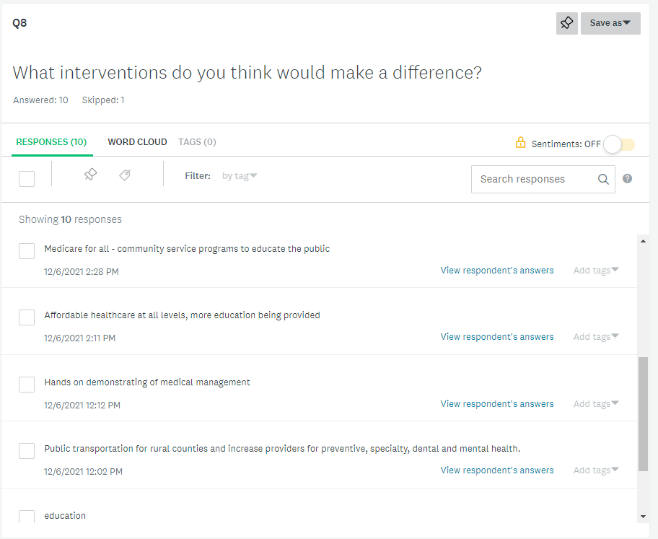

Q8 part 3: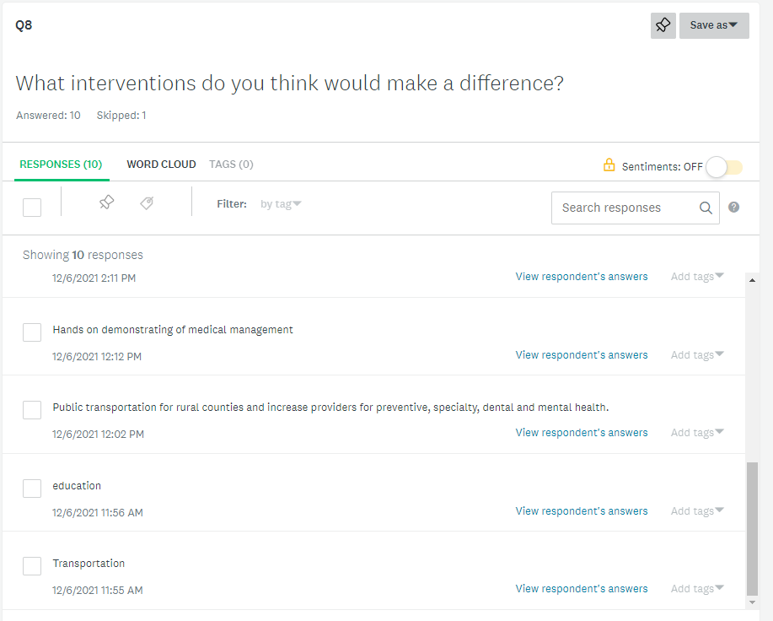

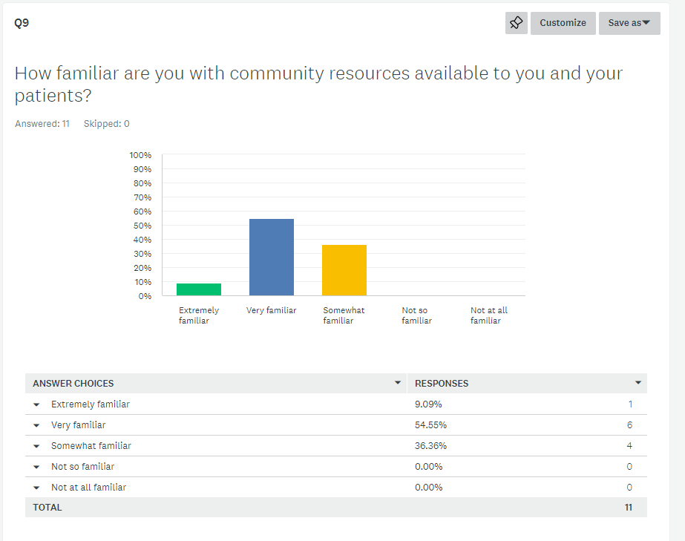

Q10 part 1: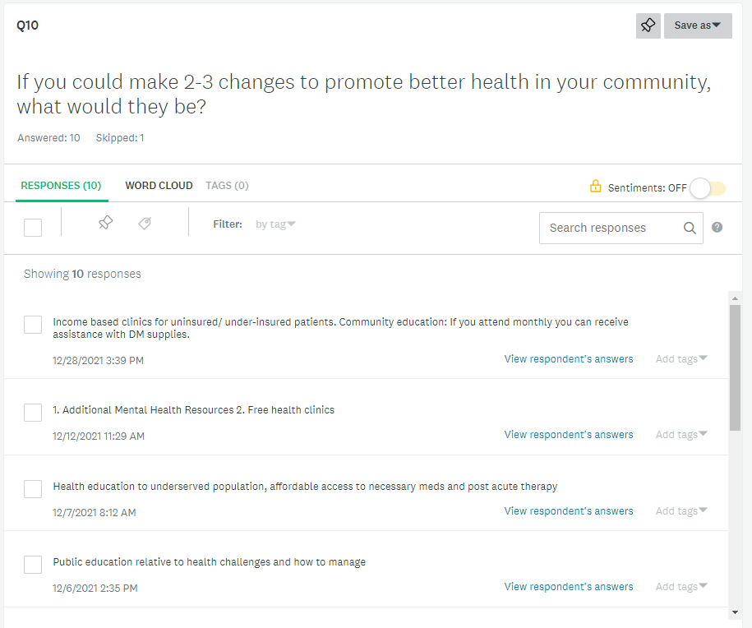

Q10 part 2: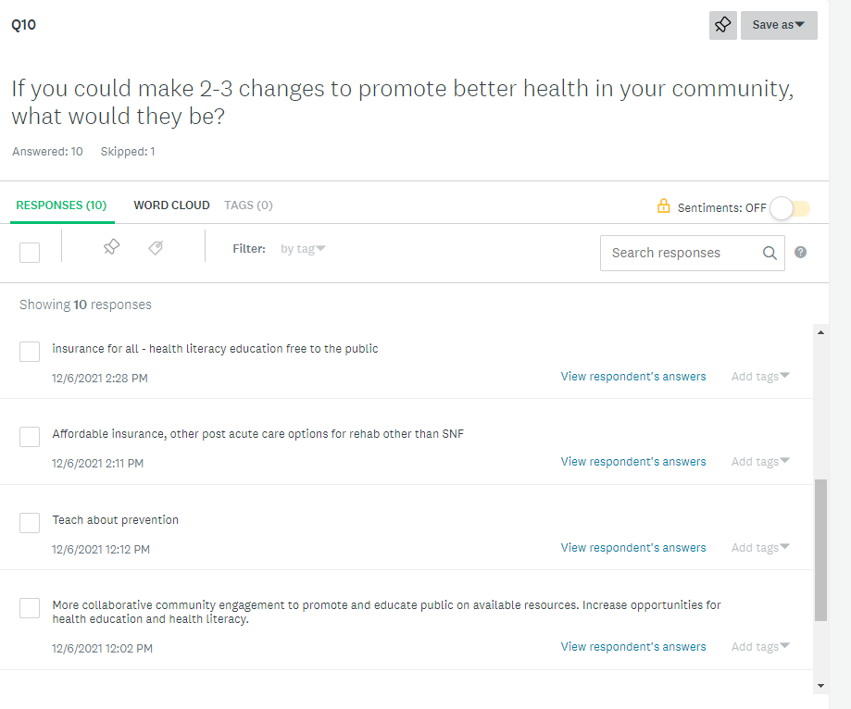

Q10 part 3: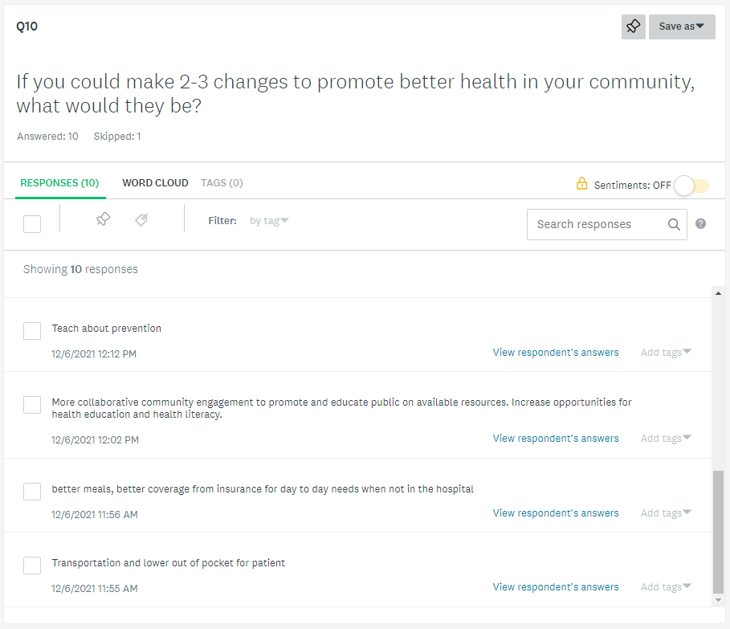

Appendix C:

General Community Survey:

Community CHNA Survey 2022 DRAFT

1. What prevents you from being as healthy as you would like to be?

High Blood Pressure

Diabetes, insulin dependent

Diabetes, adult onset

Stress

Overeating

Smoking

Alcohol, Drinking above 2 drinks per day

Other (please specify)

2. If Roosevelt Hospitals provided education to help you becom emore healthy, would you attend?

Yes

No

3. How would you like to be taught?

in person

video and/or articles posted to our facebook page

online webinar

Other (please specify)



4. What things would you like to learn about?

tips to help prevent illness/disease (High blood pressure, stroke, heart attack, etc.)

tips to eat healthier

health care resources that may be available to you

simple exercise routines

tips to stop smoking/drinking too much alcohol

Other (please specify)

Appendix D:

General Community Survey Results:

